**Time Spent: 5 Hours**

**Summary**

This program is to process calculations in plain string and provide the final answer.   
Below are the steps that the program will run:

1. First it will look for any bracket calculation in the string (eg. ( 2 – 1) ) using regex matching. If have any, it will extract it out and call itself (recursion) to process it first. After that it will replace the whole bracket calculation with the result.  
   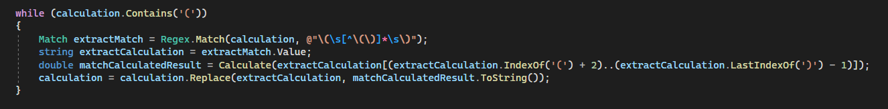
2. Then, it will split the whole string with space and populate into List of string (eg. 1 + 2 * 3 become [1,+,2,*,3])  
   
3. Next, based on sequence of * > / > - > +, it will loop through the populated list and compute the math result. Once get the result it will replace the operand and operator in the List with the result value. Then continue loop until no more operators in the list.  
   Text

   Description automatically generated  
     
   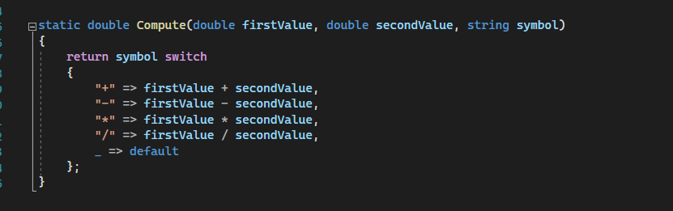

Figure : Compute method

1. Finally, return the value of first index in the list, which is the final result  
   A screenshot of a computer

   Description automatically generated with medium confidence